Debunking the Myths of OCD
By: Natascha M. Santos
https://tinyurl.com/ocd141
- Obsessive Compulsive Disorder has two aspects: (3 points)
  - The intrusive _______________, images or impulses known as _______________
  - And the behavioural _______________ people engage in to relieve the anxiety the obsessions cause
- People affected by OCD have little or no _______________ over their obsessive thoughts and compulsive behaviours which tend to be time-consuming and _______________ with work, school, or social life to the point of causing significant distress. (2 points)
- Fear of contracting an illness such as HIV from touching public surfaces is referred to as a(n) ________ whereas frequently washing your hands in scalding hot water after touching such surfaces is referred to as a(n) ________? (1 point)
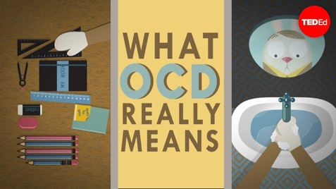
  - Compulsion; obsession
  - Delusion; compulsion
  - Obsession; compulsion
- All of the following are types of obsessions except: (1 point)
- Fear of contamination
- Scrupulosity or religiosity
- Fear of harming others
- Checking the locks
- Which of the following are treatment options for OCD? (1 point)
- SSRIs (Selective serotonin re-uptake inhibitors – medications that increase serotonin in the brain by limiting its reabsorption by brain cells)
- Behavioural therapy (Exposure and response prevention)
- Surgery
- All of the above
- Which of the following is considered to be the cause of OCD? (1 point)
- Genetics
- Specific brain abnormalities
- Still unknown
- OCD is associated with low levels of _______? (1 point)
- Epinephrine
- Serotonin
- Cortisol

